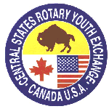
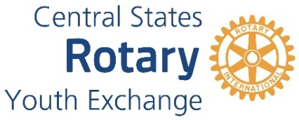

ROTARY DISTRICT 6360
YOUTH EXCHANGE PROGRAM
Club Responsibilities for
Sponsoring an Outbound Student

To Sponsor an Outbound Student, a Rotary Club must formally approve support. The factors to support the program are:

- To have a club member serve as a Youth Exchange Officer (YEO). This person will work directly with the student regarding paperwork and the selection process as well as follow-on during the exchange year.
- Promote Rotary Youth Exchange throughout your community seeking qualified students to apply. (High school foreign language classes, English classes, Interact clubs, faith-based youth groups, and 4-H groups)
- Distribute Pre-Application form to interested students and parents
- Conduct interviews of all students and parents that complete the Pre-Application Form
- Decide if the student, with supportive parents, will be a good candidate
- Refer all approved student candidates to District 6360 Outbound Coordinator for further application process.
- OPTIONAL: To provide financial support of approximately $1,000 for the year. (This can be in the form of a scholarship or providing the required RYE jacket, or other items.)
- If the student is selected to be a Rotary District 6360 Youth Exchange student, support the student and parents in the orientation process.

NEXT STEPS: See Outbound Student Timeline including estimated cost for next steps.

District 6360 RYE Team Commitment to Your Club
- District 6360 Outbound Team will work with your club YEO on processing of all required items.
- District 6360 RYE Team will provide training and information for YEO
- District 6360 RYE Team will actively support the club.

Attachments:
- Outbound Timeline
- Club Pre-Application form
- Club Pre-Application Instructions


